**Movements of the deep-water snapper *Pristipomoides filamentosus* with respect to a network of restricted fishing areas.**

**Stephen R. Scherrer1, Kevin C. Weng2**

1Department of Oceanography, University of Hawaiʻi at Mānoa, Honolulu, Hawaiʻi, USA

2 Fisheries Science Department, Virginia Institute of Marine Science, College of William and Mary, Gloucester Point, Virginia, USA

Corresponding author:

Stephen Scherrer

1000 Pope Road, MSB 609, Honolulu, Hawaiʻi, 96822, USA

Email address: Scherrer@hawaii.edu

**Abstract (200 words max)**

**Background.** Deepwater bottomfish are a significant cultural and economic resource of the Hawaiian archipelago. In an attempt to curb overfishing of key species, managers established a series of no-take areas throughout the fishery. There is a paucity of information regarding the spatial ecology of these fish in relation to enacted spatial protections. Here passive acoustic telemetry is used to examine long-term spatial use of *Pristipomoides filamentosus,* a key component of the commercial and recreational fishery.

**Methods.** 179 *P. filamentosus* were surgically implanted with acoustic tags and released between January 2017 and January 2018. Individuals were tracked within and around a restricted fishing area between June 2017 and April 2018 to determine the frequency of movement between protected and unprotected waters, describe the home range of individuals, and compare individual home ranges to the scale of spatial protections.

**Results.**

**Discussion.**

**Introduction**

Deep-water demersal fishes are a valuable economic and cultural resource throughout the Indo-Pacific. In Hawaii, commercial and recreational bottomfish fisheries use hook-and-line methods to target a multispecies complex of demersal fishes that inhabit island slopes and banks throughout the archipelago between 100 and 400-m depth (Polovina et al., 1985). Management of bottomfish resources is a partnership of federal, state, and local agencies with quantitative fishery assessment and focuses on six species of eteline snapper and one endemic grouper (Anonymous 2009). Locally these species are referred to as the Deep 7 and include *Pristipomoides filamentosus* (local name ‘opakapaka’), the species representing the highest catch abundance, followed by *Etelis courscans* (‘onaga’), *Etelis carbunculus* (‘ehu’), and *Pristipomoides sieboldii* (‘kalekale’). *Aphareus rutilans* (‘lehi’), *Pristipomoides zonatus* (‘gindai’), and the endemic Hawaiian grouper *Hyporthodus quernus* (‘hapuupuu’) make up the remainder of the seven managed species (Martell, Christensen, and Zeller, 2006). During the 2017-2018 fishing year, the ex-vessel value of these species was in excess of 1.6 million dollars[1].

Faced with an overfishing determination in 1998, an annual catch limit and a network of no-take deep-water marine protected areas were introduced as control measures to facilitate recovery of Deep 7 stocks. The Bottomfish Restricted Fishing Areas, or BRFAs as they are known, originally 19 in number, were designed to protect 20% of bottomfish habitat in the Main Hawaiian Islands (MHI) while reducing total stock mortality by 15% (National Marine Fisheries Service, 2006). Incorporating improved knowledge of preferred bottomfish habitat, in 2008 the BRFAs were restructured and reduced in number of protected areas to 12. The goal of this process was to further reduce the total mortality rate to 24% (Moffitt, Kobayashi, and Dinardo, 2006; National Marine Fisheries Service, 2006; Weng, 2013; Sackett et al., 2014).

The BRFAs and similar Marine Protected Areas operate under the assumption that conservation goals can be achieved through reductions in the use of and associated mortality within these areas and that these efforts are beneficial to the fishery as a whole. However, protected areas may fail to meet management objectives if they are of insufficient size, permitting the fishery to target vulnerable populations when individuals journey into unprotected waters. Furthermore, protection at scales too large may negatively impact those reliant on these resources, either financially or for sustenance (Kramer and Chapman, 1999; Botsford, Micheli, and Hastings, 2003; O’Dor et al., 2004; Sale et al., 2005).

The BRFAs are controversial among stakeholders. Fishers have recently lobbied managers to do away with some or all of the BRFAs and many view the system as unnecessary and ineffective (Source for lobbying claim) (Hospital and Beavers, 2011). Meanwhile, analysis of footage collected from underwater baited stereo cameras found positive increases in relative size and abundance of some species within select BRFAs (Sackett et al., 2014). NOAA, The State of Hawaii’s Department of Land and Natural Resources, and the Western Pacific Fishery Management Council, who jointly manage bottomfish resources in Hawaii, require information on the movement of bottomfish to inform the future of spatial management strategies (Weng, 2013). Understanding how component species interact with and benefit from closed areas and if these areas are of a size sufficient for the benefit fish while minimizing fisher displacement are questions of critical importance.

There is presently little empirical data on bottomfish movement to assess how the size of the protection provided by the BRFAs compares to the routine movements of the fish they are meant to protect (Ziemann and Kelly, 2007; Weng, 2013). Coarse estimates of movement potential for opakapaka have been obtained through mark-release-recapture tagging studies. An ongoing cooperative tagging program between NOAA and the Pacific Islands Fisheries Group were recaptured opakapaka (n = 111, median time at liberty = 325 days) up to 61-km from their tagging location, however most individuals appeared to move at limited scales with 86% of recovered tags recovered less than 10-km from their tagging site (O’Malley, 2015).

A handful of studies have used acoustic tracking to study the Deep 7. Moffitt and Parrish (1996) used active tracking to follow 2 juvenile opakapaka, tracking each over a period of 5-6 days. They noted crepuscular movements between day and night habitat. Ziemann and Kelly used passive acoustic telemetry to track opakapaka in 2004 (n = 12, median time at liberty = 5.80-days, 5 receiver array), 2006 (n = 5, median time at liberty = 0.21-days, 3 receiver array), and again in 2007 (n = 10, median time at liberty = 0.58-days, 7 receiver array) and reported diurnal movements and spillover from the Kahoolawe Island Reserve. Weng (2013) passively tracked ehu (n = 6, median time at liberty = 28.44-days, 8 receiver array) and onaga (n = 12, median time at liberty = 40.83-days, 8 receiver array) and found that the majority of individuals spent the majority of their time within the protective boundaries of the BRFA off the island of Niihau. However long-term fine scale movement patterns relative to the boundaries of the BRFAs, and thus the degree of protection provided by these areas to bottomfish populations remain poorly understood (Oishi and Devick, 2000; Weng, 2013; O’Malley, 2015).

The goal of this study was to investigate questions of spatial and temporal use of one of these BRFAs by opakapaka using passive acoustic telemetry. Using an array of 38 receiver stations located within and outside the boundaries of the restricted fishing area, we investigate the frequency at which individuals were observed moving between protected and non-protected habitat. We also calculate observed individual home range size and compare these estimates to the habitat available within the 12 BRFAs.

**Materials and Methods**

*Study area*

The Makapuu region (21° 33.5 N, 157° 52.5 W) was selected as the study site for this project because it contains both protected and non-protected habitat with sufficient area to capture the scale of bottomfish movements observed on the multi-island array. The area is also important to the fishery and proximate to a number of ports frequented by commercial and recreational bottomfishers.

The area is located off the Oahu’s windward side, extends outward from Makapuu Point, the south east tip of the island of Oahu north to the Lanikai peninsula. A flat broad shelf protrudes east from the island’s southern edge before terminating in deep slope to join the western side of the Kaiwi channel. To the north the shelf narrows to the north joining with a series of deeper shelves to form a number of submarine canyons. BRFA-E extends from 1.5-miles offshore westward across the shelf in line with Koko Head crater in the south, to Kailua in the north (Figure 2). The surface projected adult bottomfish habitat area, defined between the 100 and 400-m depth, contained within BRFA-E covers an approximate area of 48.6-km2.

*Receiver network array design*

The tracking array was consisted of 43 individual receiver stations. Each station consisted of an acoustic receiver (VR2-W or VR2-AR, Vemco Ltd, Halifax, Nova Scotia, Canada[2]) and acoustic release (VR2-AR, Vemco Ltd, Halifax, Nova Scotia, Canada or LRT, Sonardyne International Ltd, Yateley, Hampshire, UK) buoyed by three to four 10” deep-rated trawl floats and moored with approximately 80-kg of concrete blocks. Each mooring line was contained within a 1.5-inch PVC tube to minimize the potential for entanglement.

The tracking array was composed from several sub-array components (Figure 1). The area within the BRFA was monitored by a largely non-overlapping sparse format sub-array. Positions of the sparse sub-array components were determined in iterative stages using the Acoustic Web App telemetry optimization algorithm using 50-m and 1-km bathymetry sources (Johnson and Potemra, 2011; Pedersen, Burgess, and Weng, 2014; Smith, 2016). Sparse sub-array deployment locations were selected within the bounds of BRFA-E after constraining depth between 75 and 475-m. Aggregations of up to 100 opakapaka have been reported 2-10-m above the seafloor around the Penguin Banks area (Haight, 1989; Haight, Kobayashi, and Kawamoto, 1993; Kelley and Moriwake, 2012), so a preferred depth above the seafloor of 6-m was selected. A maximum receiver detection range of 847-m was specified using results from a deep-water range test we’ve previously reported (Scherrer et al., 2018).

In addition to the sparse array monitoring movement within the BRFA, four receiver fences, where detection regions overlapped between adjacent receivers, were located inside and outside of the BRFA along the northern and southern boundaries. These array components monitored the movement of fish into and out of the BRFA. Placement of receiver fences were optimized with respect to the receiver’s probability of detecting a tag transmission over a range of horizontal distances, the bathymetry along the target transect, upper and lower depths the gate needed to encompass, the height of the receiver off the seafloor, desired height of the water column to monitor, the swimming speed of the species, and the minimum acceptable detection rate of the gate (For further details, see appendix 1). Results of range test experiments showed that 5% of tag transmissions could be heard at a distance of 847-m from the receiver. 12.5% of tag transmissions were detectable at a distance of 765-m and 25% of tag transmissions were detectable at a distance of 545-m (Scherrer et al, 2018). Therefore, spacing between any two subsequent receivers in a fence configuration should not exceed 1530 m. To be conservative, the fence algorithm was initialized with a 12.5% detection range of 600-m and a 25% detection range of 500 m. Receiver stations were deployed as close to their target marks as feasible. Using the position of the vessel at the time of deployment as an indication of final station position, the largest distance between two receivers in any of the fence configurations was 1025 m, well within the minimum spacing requirements.

Receivers in relatively deep water are particularly susceptible to close proximity detection interference (CPDI), a phenomenon where a receiver may fail to detect transmissions from tags at close distances (Kessel et al., 2015; Scherrer et al., 2018). Results from predictive modeling indicate that CPDI was likely a factor for at depths in excess of 200 m. However, CPDI is not believed to have affected the detection when fish transited receiver fence sub-arrays as multiple transmissions would be sent by a tagged fish while in the detection range of the receiver and before encountering the CPDI affected region.

Two receiver stations from the fence sub-arrays were lost during the course of the study (Figure 2). Station 323 from the northern boundary fence inside the BRFA (325-m depth) monitored habitat between and 200 and 450m. Loosing this station resulted truncated the fence with the 25% minimum detection threshold extending to a depth of approximately 370-m rather than the full 400-m habitat extent. Station 340 (324-m depth) was lost from the southern boundary fence inside the BRFA where it monitored bottomfish habitat ranging between 220 and 330-m depth. Adjacent receivers of the southern inside fence were approximately 977-m apart and had internal tags comparable in function to those used to tag fish. The loss of this station reduced the overall detection capacity of the fence. Prior to the loss of the station, individual transmissions from the unrecovered receiver’s internal tag were detected at either adjacent receivers located to the east and west at daily rates ranging between 0.6 and 6.9% (Median = 3.4%, 1st IQR = 1.7%, 3rd IQR = 4.5%). The possibility that a tagged opakapakacould traverse the southern fence located within the BRFA undetected by adjacent receivers cannot be ruled out.

*Fish Capture and Tagging*

Fish in this study were captured with the assistance of commercial fishers using hook and line gear and hydraulic or electric line pullers. Kaka line and make dog rigs are the most common method of bottomfishing in the Hawaiian archipelago and were used to land fish during this study (Hawai‘i pelagic handline fisheries: History, trends, and current status, 2007). Hooks were baited with squid, anchovies, sardines, and/or saury for bait. When using kaka line rigs, no more than 6 baited hooks were used at a time. Palu is an attractant consisting of finely chopped bait and an occasionally a filler material such wheat chafe, rice, or oats and was released when the rig was at fishing depth to attract and aggregate bottomfish.

Once aboard the vessel, the hook from the fish’s mouth. Fish that were deemed acceptable for tagging were placed in a padded v-board cradle. The minimum size of an opakapaka eligible for tagging, V13 (non-depth recording) and a V13P (depth recording) tags were weighed to the nearest ten thousandths of a gram. The V13 tag weighted 10.2024 g and the V13P tag weighted 12.7698 g. Using the conservative 2% threshold and a species specific allometric relationship between fork length and weight (Uchiyama and Kazama, 2003). Oxygenated salt water was pumped over the gill surface using a saltwater hose or a recirculating pump. If symptoms of barotrauma were present and severe, pressure was relieved by subcutaneous puncturing of the swim bladder or the animal’s protruding stomach with a sterile 18-gauge needle.

Fish were then positioned so their ventral side faced researchers. An incision between 1.5 and 2.5-cm in length was made with a sterile scalpel along the fish’s ventral centerline in the direction of the anteroposterior axis. An acoustic tag was inserted into the peritoneal cavity with a triple antibiotic cream. Each tag transmitted a coded unique ultrasonic identifier once every 90-200 seconds (nominal transmission interval 145 seconds). V13 transmitters had an expected battery life of 2.25 years but did not have pressure sensors while V13P tags, which had pressure sensors that could be used to infer tag depth, had an expected battery life of 1.63 years. The incision was closed using sutures (Ethicon PDS*Plus antibacterial monofilament) tied with a surgeon’s knot secured first with a triple throw, then a double throw, and finally a single throw tied in alternating directions. When available, fish were tagged externally, between the lateral line and dorsal fin, with a 4-inch PDS-2 dart tag (Hallprint PTY, Inc. Hindmarsh Valley, South Australia). These tags were provided by the Pacific Islands Fisheries Group for identification as part of a long-term mark-recapture tagging program.

Deep 7 species are physoclystic, that is, the gas bladder is not open to the gastrointestinal tract. As a result, bottomfish are particularly susceptible to barotrauma injuries from rapid expansion of the swim bladder during rapid ascent following hooking (DeMartini, Parrish, and Ellis, 1996; O’Malley, 2015). Potential barotrauma injuries include organ displacement, internal hemorrhaging, and embolism. Severe injury may result in organ damage and death (Rogers, Lowe, and Fernández-Juricic, 2011). Methodological studies focusing on mitigating barotrauma in deep-water teleosts indicate that slow ascent rates, limited on-deck handling times, and rapid recompression have positive improve survivorship outcomes, but these studies have largely focused on rockfish (genus: *Sebastes*) (Parker et al., 2006; Jarvis and Lowe, 2008; Hochhalter and Reed, 2011; Rogers, Lowe, and Fernández-Juricic, 2011; Pribyl et al., 2012). External symptoms of barotrauma observed during this project included esophageal eversion and exophthalmia due to swim bladder expansion. Rapid release of air and deflation of the body cavity while making the peritoneal incision was not uncommon and likely due to rupturing of the swim bladder.

Predation by sharks, jacks, and marine mammals was also a significant source of mortality. Using SCUBA, four opakapaka were observed for periods of 30-60 minutes after they were lowered to roughly 20-m in a mesh pen (approximately 4ft high, 6.5ft diameter). None of the fish showed observable signs of severe barotrauma, however within 10 minutes, between 2 and 5 sharks were observed in near proximity to the pen. While fishing, a number of individuals were consumed partially or totally by predators during ascent. Detection records of from a number of released fish paint a similar picture with a series of rapid movements throughout the study site observed immediately after tagging followed by cessation of all movement. Such behaviors were consistent with movements of tagged sharks with movement cessation thought to occur with expulsion of the tag. It is likely that palu, an attractant used to aggregate bottomfish, also attracted predators, and exacerbated the issue.

To reduce mortality in this study, when possible, the rate at which the mainline was pulled was slowed to facilitate some compensative off gassing of the swim bladder during ascent while still pulled at a rate to limit predation. On-deck handling time never exceeded 10 minutes, with the majority of surgeries lasting no-longer than 5 minutes. Various strategies for release were attempted to balance rapid recompression and predator avoidance. Release strategies included release at the seafloor using a drop shot device (Blacktip Brand, 58 individuals), midwater release (30-60 m) using a drop shot device (Seaqualizer Brand, 70 individuals), and surface/near surface release (16 individuals). No method of release was reported for 2 individuals.

*Categorizing Fish Status*

High post-release mortality and moderate to high rates of single station residency observed in tagged fish make determining tag status non-trivial. Simply, it is difficult to be certain whether a tagged fish has died or simply did not move very far. An algorithmic process was developed to determine the status of fish detected on the receiver based on features of their tracks (Figure 3). Using this method, tracks from each tagged fish were assigned to one of three categories: expired tracks from fish that are deceased, valid tracks from fish believed to be alive, and uncertain tracks in which a track could not be determined. Tags belonging to fish consumed by predators had a strong movement signal post-tagging while the tag was presumably inside the predator’s stomach. For these tags, vertical and horizontal movement ceased within a period of 1 to 14-days. Predation/mortality status could not be determined for tags with track lengths less than 14-days. Range testing indicated that under the optimal conditions, tag transmissions could be detected by receivers up to a distance of 1000 m, fish with tracks that moved between two stations separated by more than 2000-m after the 14th-day were considered valid. If no movement was observed between stations following the 14th-day, a valid status was assigned to tracks from individuals with depth-sensing tags where vertical movement range exceeded 10-m after day 14. This threshold was selected as it is greater than the maximum fluctuation in depth that could be explained by tidal changes alone. Tags lacking depth sensors that did not move after 14 days were classified as dead if they had a strong movement signal, defined as detection at 4 or more stations during the first 14 days post-tagging. The status of tags detected at fewer than 4 stations during the 2-week period following tagging was uncertain. Visual inspection of tracks belonging to these tags were indistinguishable from stationary tags belonging to fish that were known to be dead as well as resembling highly resident fish that were known to be alive from depth records. This last group likely includes a mixture of both valid tracks from highly resident fish that were detected consistently at a single receiver and detections of stationary tags belonging to fish that expired. Is this where you go into 2 analysis scenarios?

*Testing for size selective survivorship bias*

Correlation between size and survivorship outcome for tagged opakapaka was tested by comparing the distribution of fork lengths from fish with valid tracks to the total population fish. A subset of fork lengths equal in number to the fish with valid tracks were selected at random from the total population of fork lengths without replacement. The mean and standard deviation of fork length distribution for those fish selected were calculated and the process was repeated for 10,000 iterations. These summary statistics were used to calculate confidence intervals to compare the surviving opakapaka with all fish that were tagged.

*Calculating Individual Home Range*

A linear home range estimator, referred to as the maximum movement distance observed, was used to calculate the home range size for each individual based on their known location from detection records. A number of methods for quantifying animal space use from telemetry data have been proposed and home range estimates may vary depending on the telemetry technology and method used to estimate space use (Gantz et al., 2006; Dwyer et al., 2015). This study used passive acoustic telemetry to track marine fish associated with a narrow depth band which can be thought of similar to a river winding along the depth contour and flanked by areas where individuals are less likely to occur. In similar systems, a constrained linear home range estimator has been shown to provide a more robust estimate of space-use when compared to other popular methods for quantifying home range including minimum convex polygon and kernel utilization distribution (Dwyer et al., 2015).

The maximum movement distance observed for each individual was calculated as the longest path between receivers that a given individual was detected. Because adult bottomfish habitat is defined as depths between 100 and 400m, paths between receivers were constrained to this depth range using a least-cost path algorithm using the MarMap package in R (Pante and Simon-Bouhet, 2013; R Core Team, 2014). In effect, if the line of sight path between two stations encountered an obstacle with a depth outside this range, the pathfinding algorithm would circumvent the obstacle, resulting in a longer path consistent with bottomfish spatial use.

*Comparison to BRFAs*

Maximum movement distance observed for opakapaka was compared to the distance across the BRFAs. As defined, all but one BRFA is located along a slope including both protected and unprotected habitat (Figure 5). To estimate the linear habitat dimension of each BRFA area, the same depth-constrained least-cost path algorithm was employed. For the 11 BRFAs located along slope edges, a path was calculated between the two sides of the BRFA’s boundary intersecting bottomfish habitat using 50m resolution bathymetry. The start and end points for each path was 120 m, the preferred depth of opakapaka. For the BRFA containing depths exclusively within defined bottomfish habitat, the hypotenuse between opposing corners of the rectangular area was used as the linear habitat dimension (Figure 5).

*Quantifying Spillover*

Spillover was quantified using location coordinates for each tag detection and determining if the fish was located within or outside BRFA-E’s boundaries. Movement across BRFA boundaries was said to occur when a tag was detected outside of BRFA boundaries followed by a detection within BRFA boundaries, or vice versa. The number of movements across BRFA boundaries was then standardized by the time at liberty, the number of days elapsed between tagging and the final detection of a tag.

**Results**

*Fish Capture and Tagging*

The minimum fork length of opakapakaeligible for tagging was determined to be 14-cm for V13 tags and 15 cm for V13P tags. Between 9 January 2017 and 11 January 2018, 179 opakapakawere tagged and released within the study area with 158 tag IDs detected at least once on the receiver array between 26 June 2017 and 15 April 2018 (Table 1). Of these, 68 of the detected individuals were tagged with depth sensing tags which transmit pressure data in addition to the unique tag ID.

*Survivorship*

14 tracks detected on the array between 26 June 2017 and 15 April 2018 were classified valid and a further 26 tracks were classified as uncertain. There were 76 tracks from individuals believed to be dead. 42 tracks were excluded due to insufficient data and there were no detections from 21 individuals. Presented are both a conservative scenario including only valid tracks from fish believed to be valid (14 tracks) and a less conservative scenario which includes the addition of the uncertain tracks (26 additional tracks, 40 tracks total). Under a conservative scenario considering only the 14 tagged fish with valid tracks, the survivorship/response rate was 7.9%. Time at liberty, the elapsed time between when an individual was released and its last detection on the array, was on average 202.4 days (Standard Deviation [s.d.] = 114.8). Under the less conservative scenario with the inclusion of 26 tags of uncertain status, the survivorship/response rate increases to 22.3% with an average time at liberty of 191.3 days (s.d. = 115.6). Finally, inclusion of 42 individuals with insufficient data to make a definitive status determination raises the survivorship/response rate is 46.8 %.

*Testing for size selective survivorship bias*

The mean fork length of opakapaka with tracks classified valid (44.44 cm) fell within the 95% confidence interval from simulation data sampled without replacement (43.56 - 52.82). However, the standard deviation of fork lengths of opakapakawith tracks classified valid (3.38 cm) did not fall within the 95% confidence interval from simulation data sampled without replacement (6.28 - 13.23). This result indicates that the size distribution of fish with tracks classified valid does not differ from a random subset of the total population, the largest and smallest fish tagged were under represented in the data (Figure 4).

*Calculating Individual Home Range*

Conservative Scenario – Estimates of individual depth constrained linear home range varied between 3.24-km and 9.37-km. The mean maximum observed movement distance for the 14 tags was 6.07-km (s.d. = 2.32-km). The median maximum observed movement distance was 6.02-km (1st Quantile = 3.66-km, 3rd Quantile = 8.53-km).

Less Conservative Scenario – Uncertain tracks are defined by the status algorithm as tags detected on the array but with no significant movements observed 14 days post tagging. If they are in fact alive, individuals in this category typically exhibit a high degree of site fidelity, detected continuously or with regular periodicity at a single station over long periods. Combined with the valid tracks, there was an observed but not unexpected decrease in the maximum movement distance observed for this group. The mean maximum observed movement distance for the 40 tags was 3.4-km (s.d. = 2.77-km). The median maximum observed movement distance was 2.8-km (Min = 0-km, 1st Quantile = 1.62-km, 3rd Quantile = 5.3-km, Max = 9.37-km). (Figure 7).

*Comparison to BRFAs*

The median linear dimension of the BRFA network was found to be 14.70-km (Min = 2.99, 1st Quantile = 10.65, 3rd Quantile = 19.13, Max = 54.56). With the exception of BRFA-B, home range lengths observed were less than the linear habitat dimension of all BRFAs under both conservative and less conservative scenarios.

*Quantifying Spillover*

Conservative Scenario – Eight of the 14 tracks were detected crossing the BRFA boundaries a combined total of 96 times. The mean number of BRFA crossings detected per fish was 6.86 (s.d. = 6.86). Standardized by time at liberty, the mean crossings into or out of the BRFA detected per fish per day was approximately 0.03 (s.d. = 0.03) or once every 32.18 days. However individual rates were as high as 0.075 crossings per day, equivalent to crossing once every 13.36 days. The median number of crossings observed per day at liberty was 0.03 (Min = 0, 1st Quantile = 0, 3rd Quantile = 0.06, Max = 0.07)

Less Conservative Scenario –With the inclusion of additional tags with undetermined status the number of fish detected moving across BRFA boundaries remained at 8 with a combined total of 96 crossings. The mean number of boundary crossings per fish was 2.4 (sd = 5.16). Standardized by time at liberty, the mean crossings into or out of the BRFA detected per fish per day was approximately 0.01 (s.d. = 0.03) or once every 73.95 days. However individual rates were as high as 0.099 crossings per day, equivalent to crossing once every 10.08 days. The median number of crossings observed per day at liberty was 0 (Min = 0, 1st Quantile = 0, 3rd Quantile = 0, Max = 0.1).

**Discussion**

Acoustic telemetry has an established history for evaluating the marine reserve efficacy but application at the depths in this study this species is relatively novel and presents a number of unique challenges compared to studies in shallow water environments (Arnold and Dewar 2001; Heupel et al. 2006a; Grothues 2009; Farmer et al. 2013; Pedersen et al. 2014). In this study, opakapaka were monitored using acoustic telemetry to determine the extent of movement behavior and provide information on the appropriate scales for spatial protection. For fish with tag records meeting the requirements for inclusion, observed linear home ranges were similar in magnitude and smaller than the linear habitat dimension of 11 of the 12 BRFAs. These results mirror the conclusions of previous studies looking at the movement in the species over significantly longer time scales than other reported acoustic tracking studies and with far greater detail than can be obtained using conventional mark recapture methods. Our results indicate that these protected areas are likely providing adequate protection to the opakapaka residing within the boundaries of BRFA-E. This conclusion is supported by analysis of baited camera data showing the mean fork length of opakapaka filmed inside BRFA-E increased in size in the years following protection (Sackett, Kelley, and Drazen, 2017). When broadening our comparison to include the additional 11 BRFAs, there is an explicit assumption that the scale of movements for opakapaka are similar throughout the main Hawaiian archipelago. It would be prohibitively difficult to test this assumption given effort required to tag a sufficient number of fish and the resources required for similar tracking arrays, however results from tracking in and around BRFA-E are parsimonious with those of conventional mark-recapture studies conducted elsewhere in the Main Hawaiian Islands (Kobayashi, Okamoto, and Oishi, 2008; O’Malley, 2015).

A considerable amount of array hardware associated with each receiver station was deployed over the duration of this study to operational depths exceeding those accessible by scuba, requiring deployment and recovery of receiver stations from a suitably sized vessel using of acoustic releases. Close proximity detection interference (CPDI) is a factor that must be accounted for when designing acoustic tracking arrays where deployment depths exceed 200-m (Scherrer et al 2018). CPDI occurs when a transmission’s reflected signal arrives at a receiver with sufficient timing and intensity to interfere with the direct path signal. The overlapping transmission signals are interpreted by the receiver as an invalid detection and are not logged (Kessel et al 2015, Scherrer et al 2018). Using a conservative model for predicting CPDI which assumes no energy loss at the seafloor interface and an average maximum detection range of 847-m from range testing results, the maximum extent that receivers used in this study were affected by CPDI ranges between 70-m up to a distance of 451-m for fish at a within +/-20-m of the seafloor depth at the location of the receiver. Given the nominal transmission rate of the tags used and assuming an average swimming speed of 1 body length per second, CPDI is not thought to have affected the ability of receiver fence sub-arrays to detect the passage of individuals but may result in the underestimation of residency rates if individuals spent extensive time near receivers.

The loss of 5 receiver stations reduced monitoring capacity of bottomfish habitat within the BRFA. Under the assumption of random walk behavior, theoretical unique detection rates calculated by the Acoustic Web App correspond to the percentage of habitat monitored by the receiver network. When calculated this way, it is estimated that the loss of 5 receiver stations reduced the proportion of monitored habitat from 31.0 % as planned to 24.9 % as realized. The loss of receiver station 340 from the fence sub-array inside the BRFA’s southern border introduces the potential of undetected passage for individuals transiting into and out of the BRFA. From range test results, the horizontal distance between receiver stations 339 and 341, the two stations adjacent to station 340, was approximately 1857-m. From range test results, the horizontal distance between these receivers representing the gap in the fence where detection rates fell below the prescribed 25% threshold caused by the loss of station 340, spanned an approximate horizontal distance of 789-m.

Estimates of post-release survivorship from this study are low, ranging between 7.9 and 22.3 % of fish tagged depending on the status of uncertain tracks. The low survivorship rates in this study mirror those of conventional mark-recapture work where observed recapture rates for the species were 2.5% (O’Malley, 2015) and 12% (Kobayashi, Okamoto, and Oishi, 2008). Survivorship rates as high as 66.7% were been reported for opakapaka tagged with acoustic transmitters in the Kahoolawe island reserve (Ziemann and Kelley, 2008), however survival was based on detection of the tag on at least one receiver and no further steps to ascertain survivorship were performed. When the algorithm used in this study to ascertain survivorship is applied, only 30.8% of tagged opakapaka have tracks exceeding 14 days. The two major drivers of these rates are thought to be barotrauma and predation. In the course of this and other studies, a number of tagging protocols have been developed. These protocols vary widely in their methods, some anesthetize the fish prior to surgery and often then hold the fish in a recovery tank for a period of time before release, venting of the swim bladder and whether venting is performed subcutaneously or by puncturing an everted stomach has also varied. Other variations involve whether assisted recompression devices are used during release and if so, how the fish is attached and if they are returned to the seafloor or an intermediate depth. Finally, relocation of the fishing vessel during the tagging surgery so fish are released at a location where fishing activities had not aggregated predators improved survivorship, but dramatically decreased the number of fish that could be captured. Survivorship in this study was also truncated with individuals of the smaller and larger size classes under represented. Because of the effort and cost associated with tagging large numbers of fish, a comprehensive study to determine methods for improving survivorship across all size classes should be explored prior to undertaking future tagging efforts, both in this species and for similar deep-water demersal fish.

**Conclusion**

Between January 2017 and January 2018, 146 opakapaka were tagged with coded ultrasonic transmitters and released in and around the bottomfish restricted fishing area located off of Makapuu, Hawaii (21° 33.5 N, 157° 52.5 W). The tracks of 14 fish had tracks indicating they survived the first 14 days at liberty while tracks from an additional 26 fish were uncertain in status. Fish were tracked, on average, for a period of 202.4 and 191.3-days respectively on a 39-station receiver array deployed for a period of 303 days between June 2017 and April 2018. Receivers were positioned in overlapping fences inside and outside the north and south boundaries of the BRFA and in a non-overlapping sparse array format within the BRFA. Eight opakapaka were detected moving between protected and non-protected waters with an average frequency between once every 15 – 63.3 days and a mean for those fish of 23.0 days. The other 6 opakapaka remained within the protected area for the entirety of their time at liberty. Linear home range distance was calculated for tagged opakapaka and ranged between 3.24 and 9.37-km with a mean movement distance of 6.07-km. Home ranges were smaller than the minimum distance required to traverse all but one of the 12 BRFAs. These results indicate that the scale of the BRFA network is likely to be confer protection to opakapaka residing within protective boundaries. We were unable to detect any long-range movements of opakapaka because it is not possible to detect acoustic tags beyond the range of the detection network. Future studies would be wise to first consider how variation in tagging methods may affect survivorship to resolve the high mortality rates associated with tagging these and other deep dwelling species.

**Acknowledgements**

Leonard Yamata, Craig Yamata and crew. Mike Abe and crew. Kidd Pollock, Alex Filous, Nick Cuittifetteli, Kate Berry, Gen Del Rey, Greg Burgess, Christian Squire, Keith Kamikawa, Keoni Erikson, Tom Swenarton, Jeremy Harden, Jeff Drazen, Virginia Moriwake, Chris DeMarke. This work was funded by the State of Hawaii Department of Land and Natural Resources’ Division of Aquatic Resources

# **Literature Cited**

Arnold, G., and Dewar, H. 2001. Electronic tags in marine fisheries research: A 30-year perspective. Electron. Tagging Track. Mar. Fish. 7–64

Botsford, L.W., Micheli, F., and Hastings, A. 2003. Principles for the design of marine reserves. Ecol. Appl. 13:25–31. https://doi.org/10.1890/1051-0761(2003)013[0025:PFTDOM]2.0.CO;2.

DeMartini, E.E., Parrish, F. a., and Ellis, D.M. 1996. Barotrauma-associated regurgitation of food: Implications for diet studies of Hawaiian pink snapper, Pristipomoides filamentosus (family Lutjanidae). Fish. Bull. 94:250–256

Dwyer, R.G., Campbell, H.A., Irwin, T.R., and Franklin, C.E. 2015. Does the telemetry technology matter? Comparing estimates of aquatic animal space-use generated from GPS-based and passive acoustic tracking. Mar. Freshw. Res. 66:654–664. https://doi.org/10.1071/MF14042.

Gantz, A., Meschi, F., Manica, A., and Coulson, T.I.M. 2006. Effects of sampling regime on the mean and variance of home range size estimates 1393–1405. https://doi.org/10.1111/j.1365-2656.2006.01164.x.

Grothues, T.M. 2009. A review of acoustic telemetry technology and a perspective on its diversification relative to coastal tracking arrays. *In* Tagging Track. Mar. Anim. with Electron. Devices. Vol 9. p. 77–90. Springer Science+Business Media B.V. https://doi.org/10.1007/978-1-4020-9640-2_5.

Haight, W.R. 1989. Trophic relationships, density and habitat associations of deepwater snappers (Lutjanidae) from Penguin Bank, Hawaii. University of Hawaii at Manoa.

Haight, W.R., Kobayashi, D.R., and Kawamoto, K.E. 1993. Biology and management of deepwater snappers of the Hawaiian archipelago.pdf. p. 20–27. Marine Fisheries Review 55(2).

Hawai‘i pelagic handline fisheries: History, trends, and current status 2007. Fish. Res.

Heupel, M.R., Semmens, J.M., and Hobday, a. J. 2006. Automated acoustic tracking of aquatic animals: Scales, design and deployment of listening station arrays. Mar. Freshw. Res. 57:113. https://doi.org/10.1071/MF05091.

Hochhalter, S.J., and Reed, D.J. 2011. The effectiveness of deepwater release at improving the survival of discarded yelloweye rockfish. North Am. J. Fish. Manag. 31:852–860. https://doi.org/10.1080/02755947.2011.629718.

Hospital, J., and Beavers, C. 2011. Management of the Main Hawaiian Islands Bottomfish Fishery: Fishers’ Attitudes, Perceptions, and Comments. Honolulu, HI.

Jarvis, E.T., and Lowe, C.G. 2008. The effects of barotrauma on the catch-and-release survival of southern California nearshore and shelf rockfish (Scorpaenidae, Sebastes spp.). Can. J. Fish. Aquat. Sci. 65:1286–1296. https://doi.org/10.1139/F08-071.

Johnson, P., and Potemra, J. 2011. Main Hawaiian Islands Multibeam Bathymetry Synthesis: 50-m Bathymetry and Topography. University of Hawaii at Manoa Hawaii Mapping Research Group, Honolulu, HI.

Kelley, C.D., and Moriwake, V.N. 2012. Appendix 3: essential fish habitat descriptions, Part 1: Hawaiian bottomfish. WPRFMC Final Fish. Manag. plan coral reef Ecosyst. West. 596 Pacific Reg. Vol. III, Essent. Fish Habitat Manag. ment Unit Species 597

Kessel, S.T., Hussey, N.E., Webber, D.M., Gruber, S.H., Young, J.M., Smale, M.J., and Fisk, A.T. 2015. Close proximity detection interference with acoustic telemetry: the importance of considering tag power output in low ambient noise environments. Anim. Biotelemetry 3:5. https://doi.org/10.1186/s40317-015-0023-1.

Kobayashi, D.R., Okamoto, H.Y., and Oishi, F.G. 2008. Movement of the deepwater snapper opakapaka , Pristipomoides filamentosus , in Hawaii : Insights from a large-scale tagging program and computer simulation

Kramer, D.L., and Chapman, M.R. 1999. Implications of fish home range size and relocation for marine reserve function. Environ. Biol. Fishes 55:65–79. https://doi.org/10.1023/A:1007481206399.

Martell, S.J.D., Christensen, L.B., and Zeller, D. 2006. Status and Trends of the Hawaiian Bottomfish Stocks : 1948-2004 1948–2004

Moffitt, R.B., Kobayashi, D.R., and Dinardo, G.T. 2006. Status of the Hawaiian Bottomfish Stocks, 2004. Honolulu, HI.

National Marine Fisheries Service 2006. Draft Supplmental Environmental Impact Statementbottomfish and Seamount Groundfish Fisheries of the Western Pacific Regionmeasures To End Bottomfish Overfishing in the Hawaii Archipelago. Honolulu, HI.

O’Dor, R., Lindholm, J., Oxenford, H., and Parsons, D. 2004. Acoustic Tracking of Fish : How Continuous Data on Fish Movement Could Change the Planning of MPAs. MPA news 5:1–6

O’Malley, J. 2015. A Review of the Cooperative Hawaiian Bottomfish Tagging Program of the Pacific Islands Fisheries Science Center and the Pacific Islands Fisheries Group 47. https://doi.org/10.7289/V59W0CF7.

Oishi, F.G., and Devick, W.S. 2000. Job Progress Report - Opakapaka Resource Assessment Island of Oahu. Honolulu, HI.

Pante, E., and Simon-Bouhet, B. 2013. Marmap: a package for importing, plotting and analyzing bathymetric and topographic data in R. PLoS One 8:e73051. https://doi.org/10.1371/journal.pone.0083051.

Parker, S.J., McElderry, H.I., Rankin, P.S., and Hannah, R.W. 2006. Buoyancy Regulation and Barotrauma in Two Species of Nearshore Rockfish. Trans. Am. Fish. Soc. 135:1213–1223. https://doi.org/10.1577/T06-014.1.

Pedersen, M.W., Burgess, G., and Weng, K.C. 2014. A quantitative approach to static sensor network design. Methods Ecol. Evol. 5:1043–1051. https://doi.org/10.1111/2041-210X.12255.

Polovina, J.J., Moffitt, R.B., Ralston, S., Shiota, P.M., and Williams, H. a 1985. Fisheries Resource Assessment of the Mariana Archipelago, 1982-85. Mar. Fish. Rev. 47:19–25

Pribyl, A.L., Schreck, C.B., Parker, S.J., and Weis, V.M. 2012. Identification of biomarkers indicative of barotrauma and recovery in black rockfish Sebastes melanops. J. Fish Biol. 81:181–196. https://doi.org/10.1111/j.1095-8649.2012.03322.x.

R Core Team 2014. R: A Language and Environment for Statistical Computing. Vienna, Austria.

Rogers, B.L., Lowe, C.G., and Fernández-Juricic, E. 2011. Recovery of visual performance in rosy rockfish (Sebastes rosaceus) following exophthalmia resulting from barotrauma. Fish. Res. 112:1–7. https://doi.org/10.1016/j.fishres.2011.08.001.

Sackett, D.K., Drazen, J.C., Moriwake, V.N., Kelley, C.D., Schumacher, B.D., and Misa, W.F.X.E. 2014. Marine protected areas for deepwater fish populations: An evaluation of their effects in Hawai’i. Mar. Biol. 161:411–425. https://doi.org/10.1007/s00227-013-2347-9.

Sackett, D.K., Kelley, C.D., and Drazen, J.C. 2017. Spilling over deepwater boundaries: Evidence of spillover from two deepwater restricted fishing areas in Hawaii. Mar. Ecol. Prog. Ser. 568:175–190. https://doi.org/10.3354/meps12049.

Sale, P.F., Cowen, R.K., Danilowicz, B.S., Jones, G.P., Kritzer, J.P., Lindeman, K.C., Planes, S., Polunin, N.V.C., Russ, G.R., Sadovy, Y.J., and Steneck, R.S. 2005. Critical science gaps impede use of no-take fishery reserves. Trends Ecol. Evol. 20:74–80. https://doi.org/10.1016/j.tree.2004.11.007.

Scherrer, S.R., Rideout, B.P., Giorli, G., Nosal, E.-M., and Weng, K.C. 2018. Depth- and range-dependent variation in the performance of aquatic telemetry systems: understanding and predicting the susceptibility of acoustic tag–receiver pairs to close proximity detection interference. PeerJ 6:e4249. https://doi.org/10.7717/peerj.4249.

Smith, J.R. 2016. Multibeam backscatter and bathymetry synthesis for the Main Hawaiian Islands, Final Technical Report

Uchiyama, J.H., and Kazama, T.K. 2003. Updated Weight-on-Length Relationships for Pelagic Fishes Caught in the Central North Pacific Ocean and Bottomfishes from the Northwestern Hawaiian Islands. Fish. Sci. 1–34

Weng, K.C. 2013. A pilot study of deepwater fish movement with respect to marine reserves. Anim. Biotelemetry 1:17. https://doi.org/10.1186/2050-3385-1-17.

Western Pacific Regional Fishery Management Council 2009. Fishery Ecosystem Plan for the Hawaii Archipelago. Honolulu, HI.

Ziemann, D.A., and Kelley, C.D. 2008. Detection and Documentation of Bottomfish Spillover from the Kahoolawe Island Reserve, Phase III. Honolulu, HI.

Ziemann, D.A., and Kelly, C. 2007. Detection and Documentation of Bottomfish Spillover from the Kahoolawe Island Reserve. Kahului, HI.

**Tables**

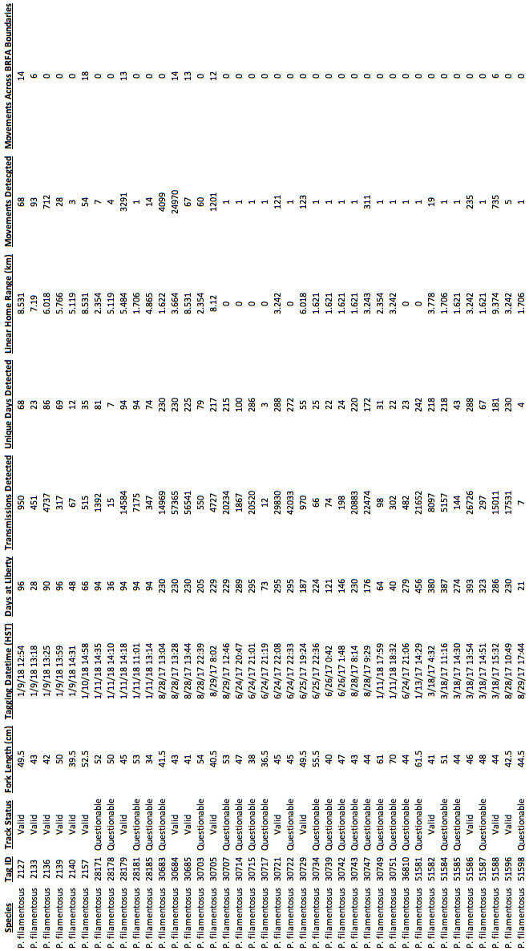

**Figures**

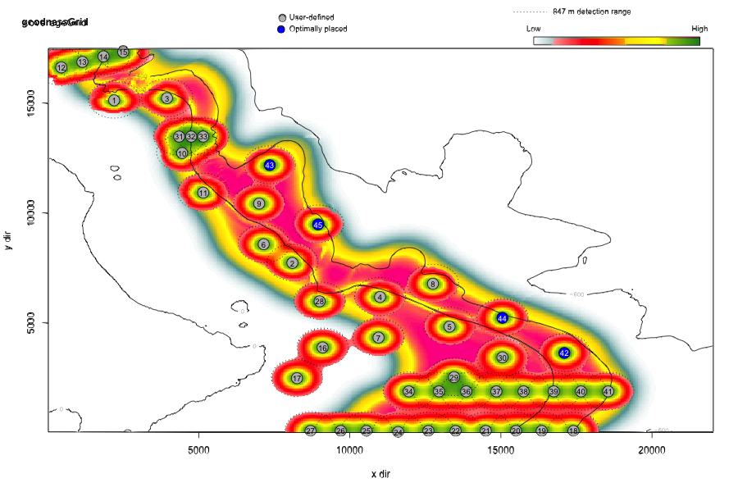

Figure 1: Combined outputs from the Acoustic Web App showing the coverage of the receiver array network in BRFA-E and the surrounding study site. Positions of each receiver station (grey numbered circles) and the probability of detecting a tag at range (heat colored circles around each receiver) relative to adult bottomfish habitat between the 100 and 400-m bathymetric contours (pink-teal heat map swath). Note that receiver numbers assigned by the Acoustic Web App are arbitrary and do not correspond to the station IDs referenced below.



Figure 2: Chart showing the station array deployed during FY2018. The boundaries of BRFA-E are shown by the purple bounding box. Receiver stations that were successfully deployed, recovered, and downloaded are indicated by the solid red circles. Numbered outlines circled in red indicate the locations where station could not be recovered (station loss, data failure). Adult bottomfish habitat (100-400 m) is highlighted in light blue.

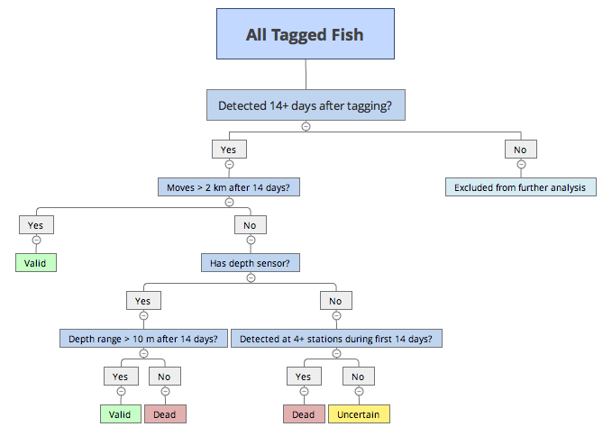

Figure 3: The FY2018 mortality decision algorithm that was used to classify each tagged fish from their detection record.



Figure 4: The distribution of fork lengths for tagged P. filamentosus with valid tracks (Top Left) and all P. filamentosus tagged during the duration of the project (Bottom Left). Simulation results show that while the observed distribution mean for fork lengths of fish with tracks classified valid (blue line) fell within the range expected from the total population data (Top Right), the observed standard deviation of the distribution (blue line) was smaller than would be expected if survivorship was random (Bottom Right).

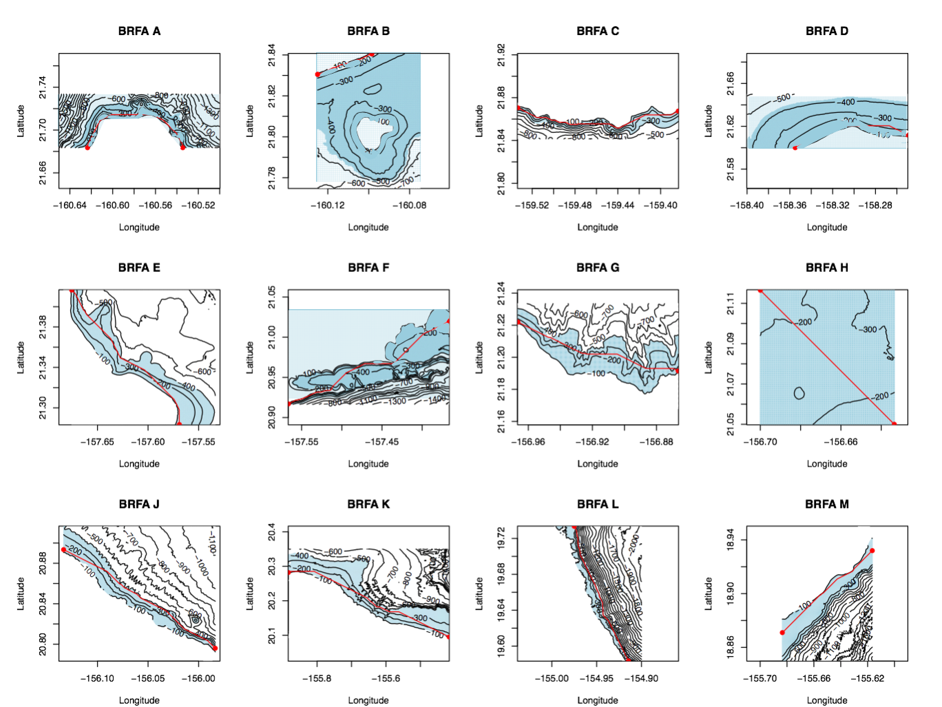

Figure 5: Maps of the 12 BRFAs used to calculate their linear habitat dimension. The least cost path approach calculated the distance across the BRFA starting and ending at the 120-m contour. The blue highlighted area indicates the 100 – 400-m depth range used to constrain each path. The red line shows the shortest (least-cost) path through the BRFA.

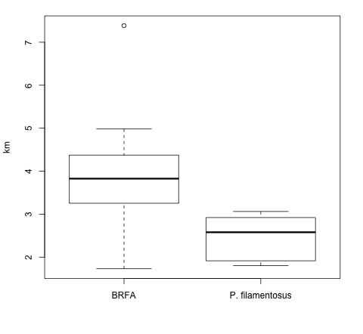

Figure 6: Comparison of the maximum movement distances observed for P. filamentosus to the linear habitat dimensions of the BRFAs under the conservative scenario (Valid tracks only).



Figure 7: Comparison of the maximum movement distances observed for P. filamentosus to the linear habitat dimensions of the BRFAs under the less-conservative scenario (Valid and Uncertain Tracks).







1. Harding, K. 2018. Personal commun. State of Hawaii Department of Land and Natural Resources Division of Aquatic Resources, Honolulu, HI
2. Mention of trade names or commercial companies is for identification purposes only and does not imply endorsement by the National Marine Fisheries Service, NOAA.